1. AWS Dashboard Modification

For using additional cameras, use the Create a new signaling channel option in the AWS console:

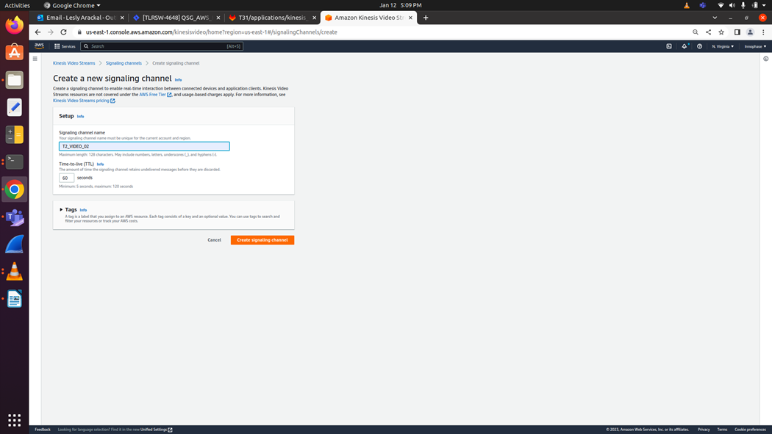

Figure 16: Creating a new signaling channel

1. CLI Command Modification

Modify the CLI command to include the new signaling channel (refer step 6 (Method 1: Manual Setup) of section: T31z INP3201 Host - Talaria TWO AWS KINESIS Video Streaming Setup):

|  |
| --- |
| /system/awskvs/kvswebrtcmaster-static <new signaling_channel name> |

1. Script Modification

Update the new signaling channel name in start_stream.sh script file as parameter to kvswebrtcmaster application.

**Note**: As mentioned in step 2 (Method 2 – Automated Shell Scripts) of section: T31z INP3201 Host - Talaria TWO AWS KINESIS Video Streaming Setup, modify the signaling channels to include the new signaling channel:

* 1. echo “.kvswebrtcmaster-static RPI4B_VIDEO”
  2. /system/awskvs/kvswebrtcmaster-static RPI4B_VIDEO